CS 4354 Database Systems
Final Exam

Name:___Chen Zhang__________________

Question 1 (8 points)
Consider the ER diagram shown in the Figure for part of a STUDENT_RECORD database.
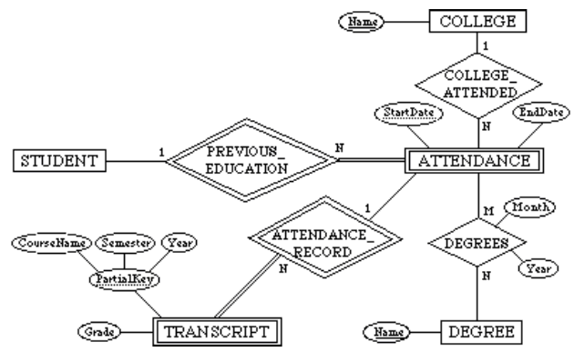

(a) List the strong entity types in the ER diagram.

Answer:
COLLEGE
STUDENT
DEGREE

(b) Is there a weak entity type? If so, give its name, its partial key, and identify which entity type it belongs to.

Answer:
TRANSCRIPT
Partial key is PartialKey which consist by CourseName/Semester/Year
Belongs to ATTENDANCE_RECORD

ATTENDANCE
Partial key is StartDate
Belongs to PREVIOUS_EDUCATION

(c) List the names of all relationship types, and explain the meaning of each relationship, including all cardinal ratios and total/partial participation

Answer:
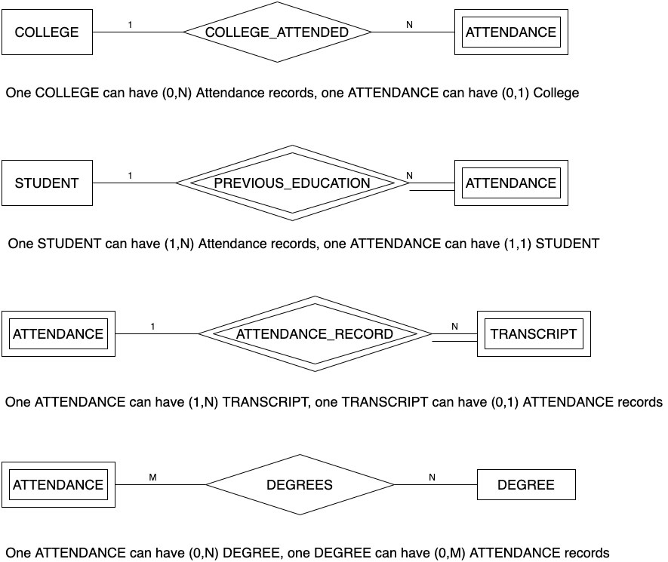
Question 2 (8 points)
Please convert the following EER Diagram into relational database schema. State any assumptions you make if you have.

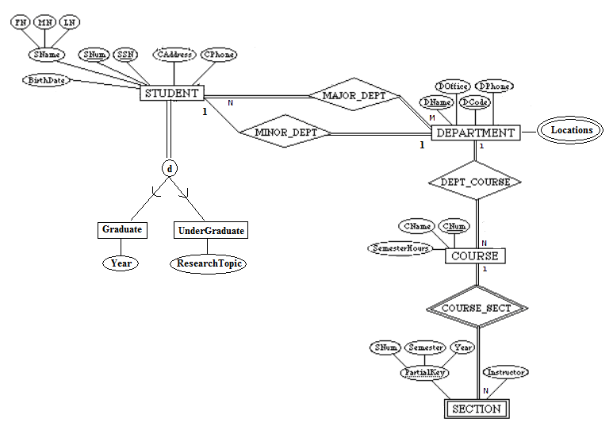
Answer:
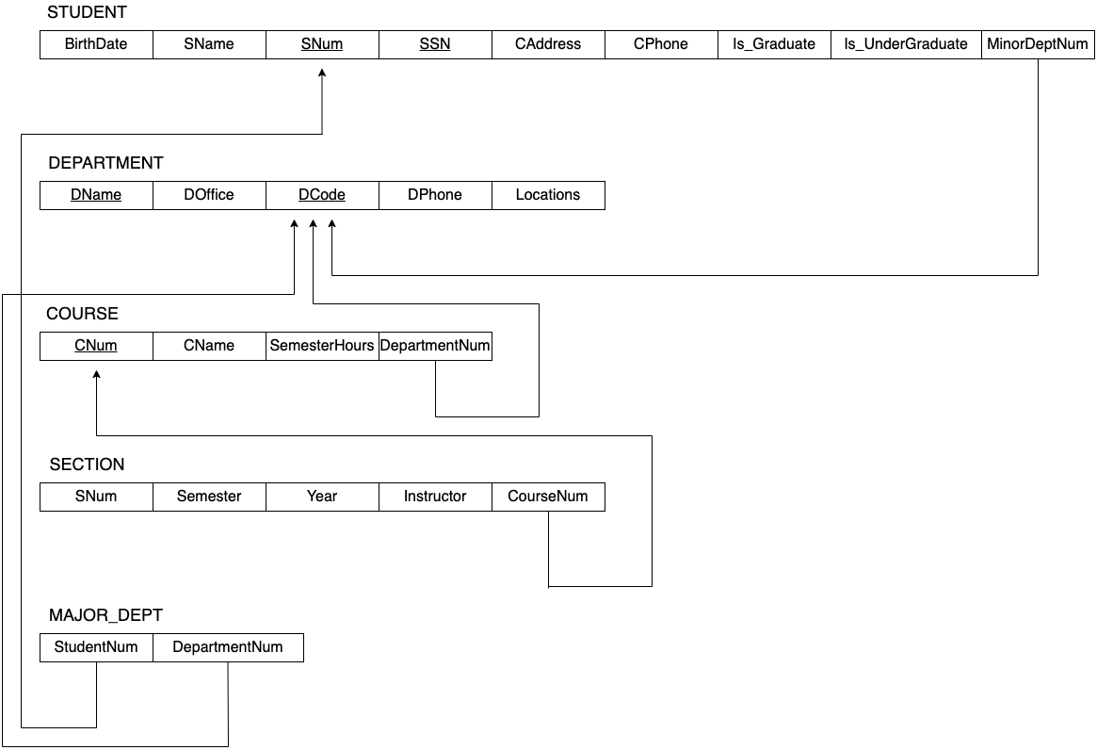

Question 3 (8 points)
Write Oracle DDL code to construct the database shown in the figure. (The code should include the declaration of Primary Key, Foreign Key, and referential triggered actions.)
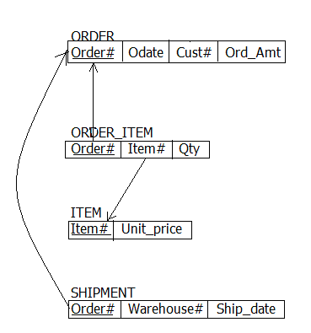

Answer:

CREATE TABLE ORDER (Order# char(10) NOT NULL, Odate date, Cust# char(10), Ord_Amt INTEGER, PRIMARY KEY (Order#));

CREATE TABLE ORDER_ITEM (Item# char(10), Qty INTEGER, FOREIGN KEY (Order#) REFERENCES ORDER (Order#) ON DELETE CASCADE ON UPDATE CASCADE);

CREATE TABLE ITEM (Unit_price DECIMAL(5,2), FOREIGN KEY (Item#) REFERENCES ORDER_ITEM (Item#) ON DELETE CASCADE ON UPDATE CASCADE);

CREATE TABLE SHIPMENT (Warehouse# char(10), Ship_date date, FOREIGN KEY (Order#) REFERENCES ORDER (Order#) ON DELETE CASCADE ON UPDATE CASCADE);

Question 4 (8 points)
Specify the following queries in SQL on the COMPANY relational database schema shown in Figure 9.2. Show the result of each query if it is applied to the following COMPANY database.

- Retrieve the names of all employees in department 5 who work on the ProductX project.
- List the names of all employees who have a dependent with the same first name as themselves.
- Find the names of all employees who are directly supervised by ‘Franklin Wong’.
- Retrieve the names of all employees whose supervisor’s supervisor has '888665555' for Ssn.

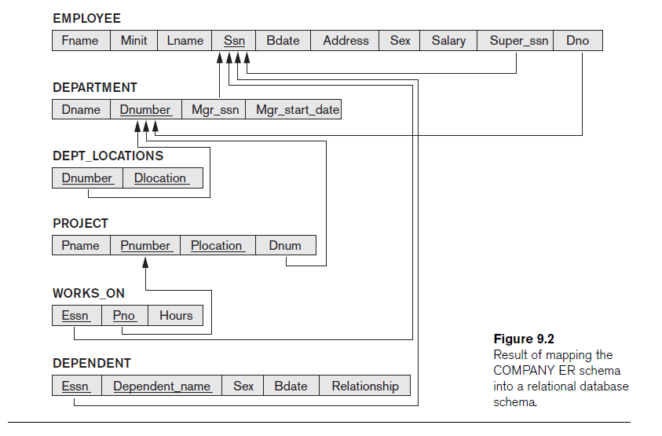
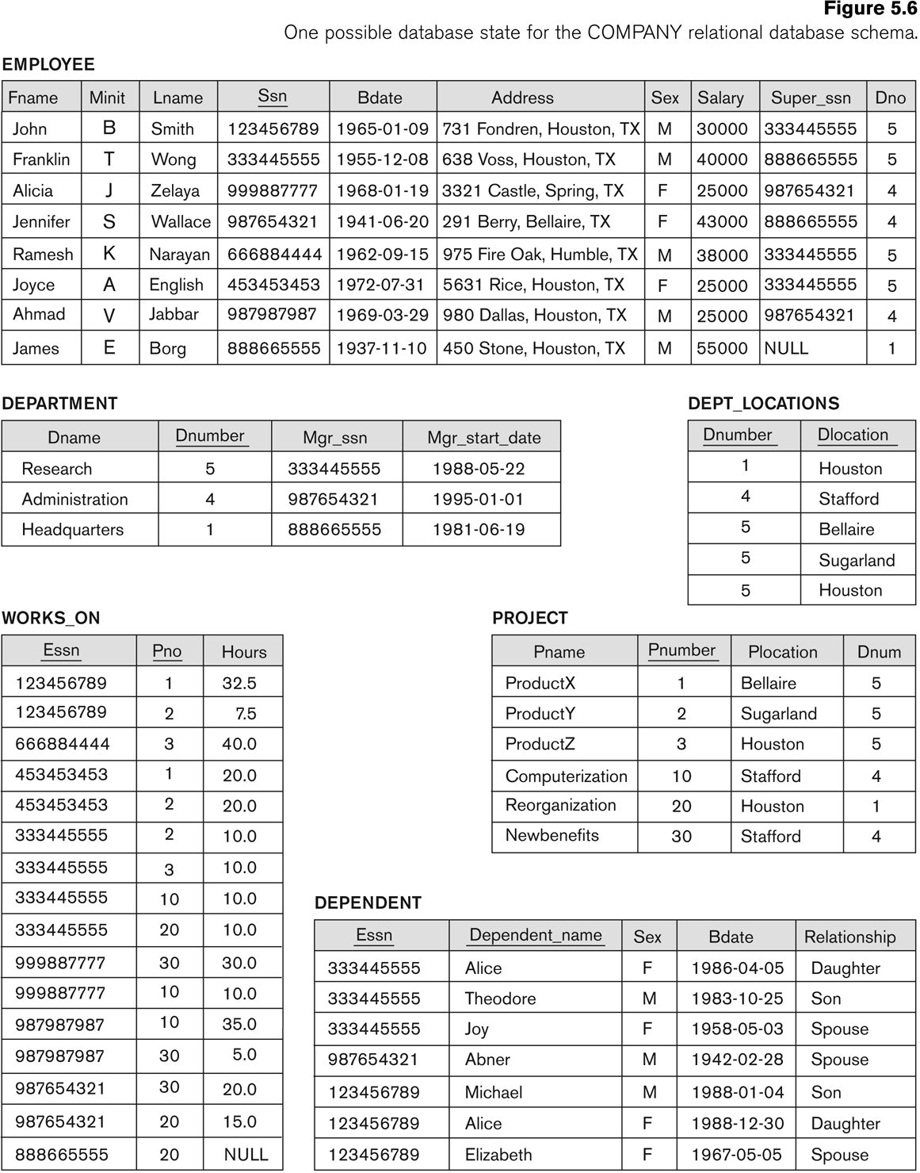

Answer:
- SELECT e.Fname, e.Lname FROM EMPLOYEE e, WORDS_ON w, PROJECT p WHERE p.Dnum=5 and e.Ssn=w.Essn and w.Pno=p.Pnumber and p.Pname=’ProductX’;
Result:
Johe Smith
Joyce English

- SELECT e.Fname, e.Lname FROM EMPLOYEE e, DEPENDENT d WHERE e.Ssn=d.Essn AND e.Fname=d.Dependent_name;
Result:
Empty

- SELECT e.Fname, e.Lname FROM EMPLOYEE e, EMPLOYEE s WHERE s.Fname=’Franklin’ AND s.Lname=’Wong’ AND e.Super_ssn=s.Ssn;
Result:
John Smith
Ramesh Narayan
Joyce English

- SELECT e.Fname,e.Lname FROM EMPLOYEE e WHERE e.Super_ssn IN (
SELECT e.Ssn FROM EMPLOYEE e WHERE e.Super_ssn='88866555'
);

Result:
John Smith
Ramesh Narayan
Joyce English
Alicia Zelaya
Ahman Jabbar

